WEEK - 1

DATA CLEANING AND TRANSFORMATION REPORT

Introduction :
Power BI is a tool used to work with data and create reports and dashboards. In this task, I used Power BI to import and clean a dataset using Power Query Editor. I checked the data types, corrected the required columns, cleaned the text data, checked for blank and error values, and worked with the Order Date column. I also created Month, Month Name, and Quarter information from the date data. Finally, I checked the cleaned data and applied the changes in Power BI.

Objectives :
- To import the dataset into Power BI.
- To check and correct the data types.
- To change date columns into the correct Date type.
- To clean the data using Trim and Clean.
- To check blank, empty, null, and error values.
- To work with the Order Date column.
- To create Month, Month Name, and Quarter information.
- To rename the required columns.
- To check the final cleaned data.
- To load the cleaned data into Power BI.

Tools and Dataset :

For this task, I used Microsoft Power BI Desktop. I used Power Query Editor to import, clean, and transform the dataset. The dataset was downloaded and saved on my computer before starting the task.
Tool Used: Microsoft Power BI Desktop
Dataset Name: samplesuperstore

Step 1 – Importing the Dataset
First, I opened Power BI Desktop and imported the downloaded dataset. After importing the file, I opened it in Power Query Editor. Power Query Editor was used to check and clean the data.

Steps Followed
- Opened Power BI Desktop.
- Clicked Home.
- Selected Get Data.
- Selected the required file type.
- Selected the downloaded dataset.
- Clicked Open.
- Checked the data preview.
- Clicked Transform Data.
- The dataset opened in Power Query Editor.

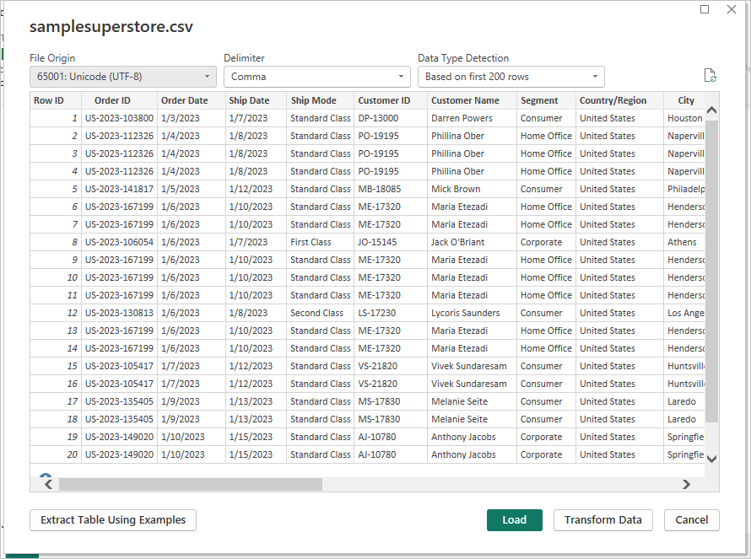

Step 2 – Checking and Changing Data Types
After importing the dataset, I checked the data type of each column. I made sure that each column had the correct data type. This is important because Power BI needs the correct data type to work with the data properly.

Steps Followed
- Opened the dataset in Power Query Editor.
- Selected the column that I wanted to check.
- Checked the data type shown near the column name.
- If the data type was wrong, selected the column.
- Right-clicked on the column.
- Selected Change Type.
- Selected the required data type.
- For text columns, selected Text.
- For number columns, selected Whole Number or Decimal Number.
- For date columns, selected Date.
- If a confirmation message appeared, selected Replace Current.
- Repeated the same process for other columns where required.

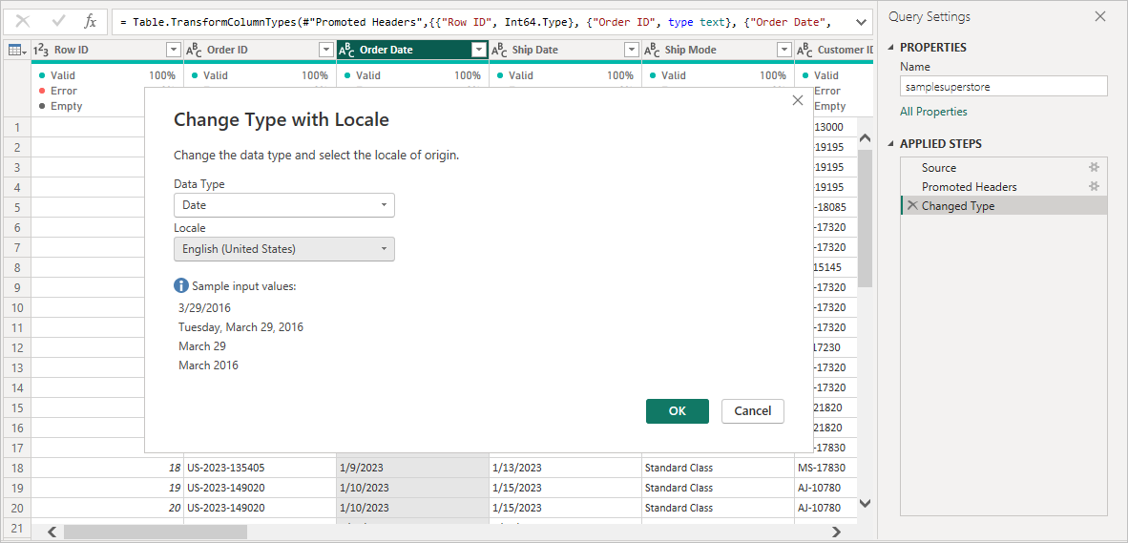

Step 3 – Cleaning the Data Using Trim and Clean
After checking the data types, I cleaned the text data. Extra spaces and unwanted characters can make the data inconsistent. So, I used the Trim and Clean options in Power Query.

Steps Followed
- Selected the required text column.
- Right-clicked on the column.
- Selected Transform.
- Selected Format.
- Selected Trim.
- Checked the data after applying Trim.
- Selected the required text column again.
- Selected Transform → Format → Clean.
- Checked the data after applying Clean.
- Repeated the same process for other text columns if required.
Trim was used to remove extra spaces.
Clean was used to remove unwanted non-printable characters.

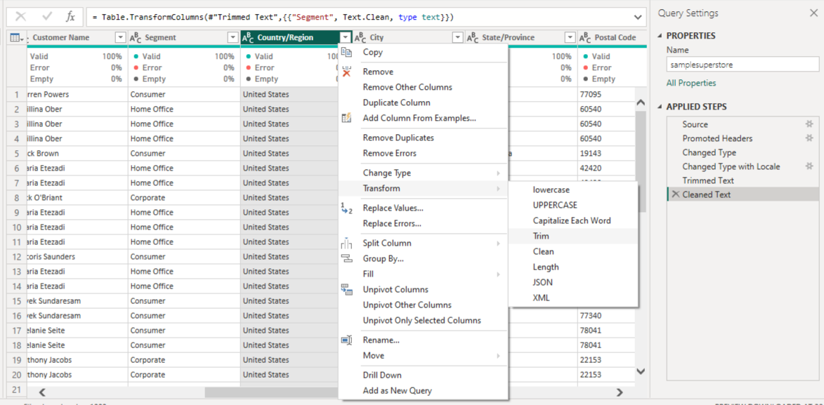

Step 4 – Checking Blank, Empty, Null and Error Values
After cleaning the data, I checked whether the dataset contained any blank, empty, null, or error values. This helped me identify any data problems before continuing with the transformation.

Steps Followed
- Selected the required column.
- Clicked the Filter option on the column.
- Checked the values shown in the filter list.
- Looked for blank or empty values.
- Checked for null values.
- Checked whether any Error values were present.
- Reviewed the columns where such values were found.
- Handled the values as required.
- Rechecked the column after cleaning.

Step 5 – Creating Month, Month Name and Quarter
After changing the Order Date to the correct Date type, I used the Order Date column to get useful date information. I created the required Month, Month Name, and Quarter information for further analysis.

Steps Followed
- Selected the Order Date column.
- Went to the Add Column tab.
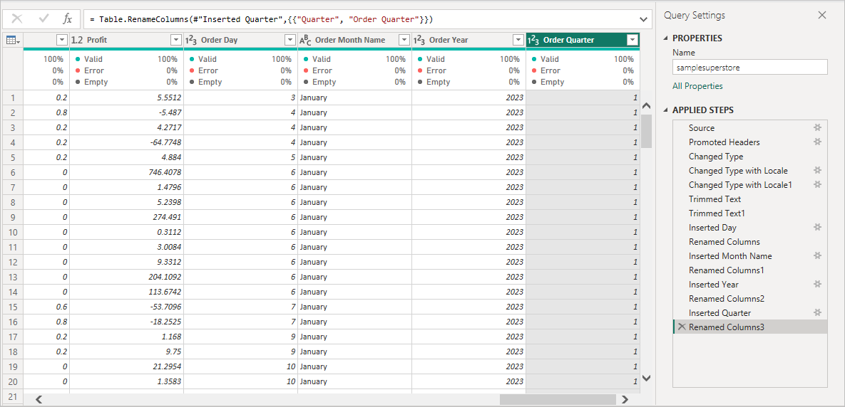
- Used the available Date options.
- Selected the required option to create the Month information.
- Created the Month Name from the Order Date.
- Created the Quarter information from the Order Date.
- Checked the new columns.
- Made sure that the values were correct.
These columns can be useful for monthly and quarterly analysis in Power BI.

Step 6 – Final Data Validation
After completing all the cleaning and transformation steps, I checked the dataset one more time. This was done to make sure that the changes were correct and the data was ready for further analysis.

Final Checks
- Checked the data types.
- Checked the Order Date column.
- Checked Month, Month Name, and Quarter columns.
- Checked blank and empty values.
- Checked null values.
- Checked error values.
- Checked the cleaned text data.
- Checked the renamed columns.
- Reviewed the final dataset.

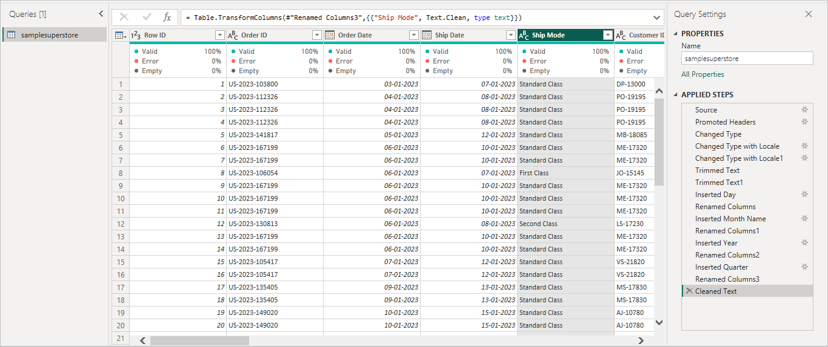

Step 7 – Close and Apply
After completing the cleaning and transformation process, I applied the changes to Power BI.

Steps Followed
- Checked the final dataset in Power Query Editor.
- Went to the Home tab.
- Clicked Close & Apply.
- Waited for Power BI to apply the changes.
- The cleaned dataset was loaded into Power BI.

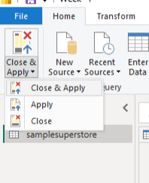

Final Result :
The dataset was successfully imported, cleaned, and transformed using Power BI and Power Query Editor. The data types were checked and corrected, and the text data was cleaned using Trim and Clean. Blank, empty, null, and error values were also checked. The Order Date column was changed to the correct Date type, and Month, Month Name, and Quarter information were created. The required column was renamed, and the final dataset was checked before applying the changes. The cleaned dataset was then loaded into Power BI.

Conclusion:
In this task, I successfully learned how to import, clean, and transform data using Microsoft Power BI and Power Query Editor. I started by importing the dataset and checking the data types of the columns. I then corrected the required data types and cleaned the text data using Trim and Clean. I also checked for blank, empty, null, and error values to improve the quality of the data. The Order Date column was changed to the Date type, and useful information such as Month, Month Name, and Quarter was created. Finally, I checked the cleaned dataset and used Close & Apply to load the changes into Power BI. This task helped me understand the basic steps involved in preparing data before using it for analysis and creating reports.

